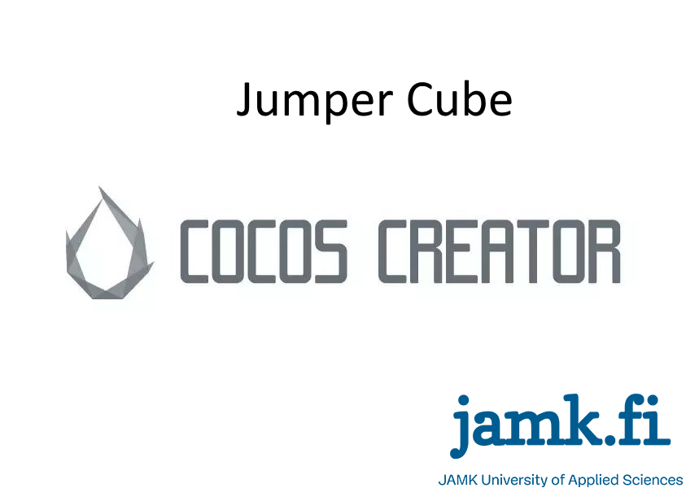

**Contents**

1. Introduction
2. Objectives
3. Use Cases
4. Usage Workflow
5. OOP
6. UML
7. Mockup (Screenshots)
8. Database Planning
9. Workloand and time planning
10. **Introduction**

This documentation holds information regarding the game planned to make, to be more exact about its purpose, structure, scope, goals, and desired outcome.

* The basic motive of this project is to learn Cocos creator and make a game which might be sellable on the store later.
* The basic target of this project are people who using Mobile devices.
* The project will deliver a new game.

1. **Objectives**

The Objectives of this project is to deilver a quality game for possible users and customers. The secound intention is to get some profit out of this project if its successful.

* Functional Objectives are to have a game which people able to play on their mobile device
* Strategic Objectives are to let people know a new developer who might provide quality software in time.
* Business Objectives are to get some profit out of the project
* Technological Objectives are to master Cocos Creator for further development of games.
* Quality Objectives are to refine the quality of codes.
* Other Objectives are to learn Java script to for further usage.

1. **Use Cases**

**Start Menu**

**Use Case 1: Game on Start**

**Actor**: User

**Workflow**:

* User starts the application on his Mobile Device
* The application starts up

**Main Menu**

**Use Case 2: Menu**

**Actor**: User

**Workflow**:

* User choses the Start option
* The system loads up the first stage.
* The system shows the hints how to play
* The user confirm to start

**Alternative** **Workflow**:

* User choses to quiet
* The game stops

**Game Level**

**Use Case 3: Playing the Game**

**Actor**: User

**Workflow**:

* System Generates the map
* System prepare the stage for play.
* User start playing

**Alternative** **Workflow**:

* User choses to quiet
* The game stops

**Settings Menu**

**Use Case 4: Option**

**Actor**: User

**Workflow**

* User chose the settings option.
* System loads the elements
* User change the settings.
* User go back to main menu.

1. **Usage Workflow**

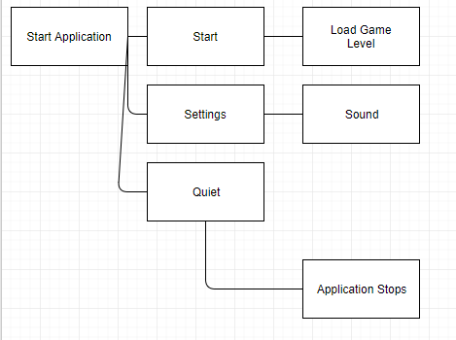

1. **OOP**

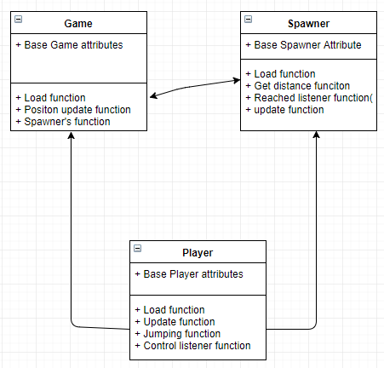

1. **UML**

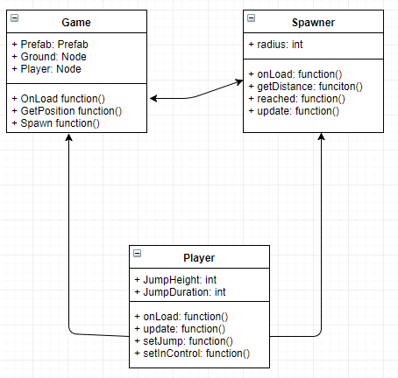

1. **Mockup (Screenshots)**
2. **Database Planning**

**JSON**

1. **Workloand and time planning**

**Workload**:

Due to other courses and Workplace in finland workload is High and strict.

**Time Planning:**

From Week 42 – Week 50:

8 -16 hours a week.